1. Overview of data and columns

select * from online_retail

1. See when the first customer bought something(almost the time when the store opened) and the last one

select distinct customerid,to_date(invoicedate,'mm/dd/yy') , dense_rank () over (order by to_date(invoicedate,'mm/dd/yy')) as rank

from online_retail

where customerid !=''

order by rank

limit 1

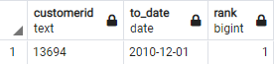

The first customer has id 13694 and the first date is 2010-12-01 to make a transaction

We can change some attributes in query to get the last Customer

select distinct customerid,to_date(invoicedate,'mm/dd/yy') , dense_rank () over (order by to_date(invoicedate,'mm/dd/yy')) as rank

from online_retail

where customerid !=''

order by rank desc

limit 1

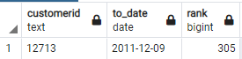

1. Check which customers paid more for us so we can collect them info and give them discounts or something

select customerid , max(summ)

from (select distinct customerid , sum(unitprice) over (partition by customerid ) summ

from online_retail) as one

where customerid !=''

group by customerid

order by max desc;



1. Most sold item over Time so we can think of providing it much more

select description , max(cou)

from

(select distinct description , sum(quantity) over (partition by description ) as cou

from online_retail ) as one

group by description

order by max desc

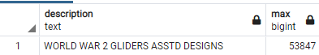

1. Minimum sales country as we can think of increase marketing or ads on it

select distinct country , sum(unitprice*quantity) over (partition by country)

from online_retail

order by sum asc

limit 1

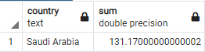

1. Country that we get maximum customers from it

select distinct country , count(customerid) over (partition by country)

from online_retail

order by count desc

Limit 1

